**IT113-IT FUNDAMENTALS**

**FINAL PROJECT**

https://josemarirosalim.github.io



**Ronel Bongga**

**Instructor**

**Submitted by:**

**Josemari Rosalim**

**INTRODUCTION**

1. ***Background Information***

The IT111 Web Design Project assesses our comprehension of web development concepts as well as our capacity to refine our design talents. The project is well-organized, with three unique navigation menus which is the Homepage, IT111 Blog Entries, and the Flex Page. The Homepage acts as a virtual introduction, including vital features such as a profile photo, name, and a kind greeting to the reader. It also includes dynamic social networking buttons that connect users to our personal accounts. Notably, the site acts as a canvas for us to display not only our technological skill but also our future ambitions, with the possibility of presenting ourselves in the form of a movie or infographic in 8 years.

The IT111 Blog Entries area transforms into a reflective arena where we may articulate and share our academic experience. We may dive into our outputs and learnings, as well as identify the problems that influenced our experiences during the first semester of the academic year 2023-2024, here. This blog section serves as a reservoir of information as well as a tribute to our progress and adaptation in the face of academic obstacles.

The Flex Page, on the other hand, expands as a dynamic portfolio, showcasing our expertise in graphic design projects. It provides precise area for us to display our creative work. Furthermore, the flex page condenses our knowledge of software development, front-end development, and productivity tools. This holistic approach not only demonstrates our technical strengths, but also highlights the breadth of our expertise in the realms of IT and design.

In essence, the IT111 Web Design Project is a creative journey that stimulates self-expression, contemplation, and the comprehensive presentation of our talents and objectives in the ever-changing world of web development.

1. ***Chosen Web Hosting Service***

I choose Github for web hosting services because it is a web hosting service that allows customers to easily host and exhibit their static websites straight from their GitHub repositories. It is a popular web hosting option due to its seamless connection with Git version control, which provides a quick and clear approach for distributing changes. GitHub Pages is especially useful for personal and small-scale projects since it provides free hosting and automated deployment. Its support for custom domains gives it a professional appearance, and the option to utilize Jekyll streamlines content development by allowing users to write in Markdown. Overall, GitHub Pages is a dependable and straightforward hosting solution, particularly for developers who value version control and cooperation inside the GitHub ecosystem.

**Conceptual Design**

1. 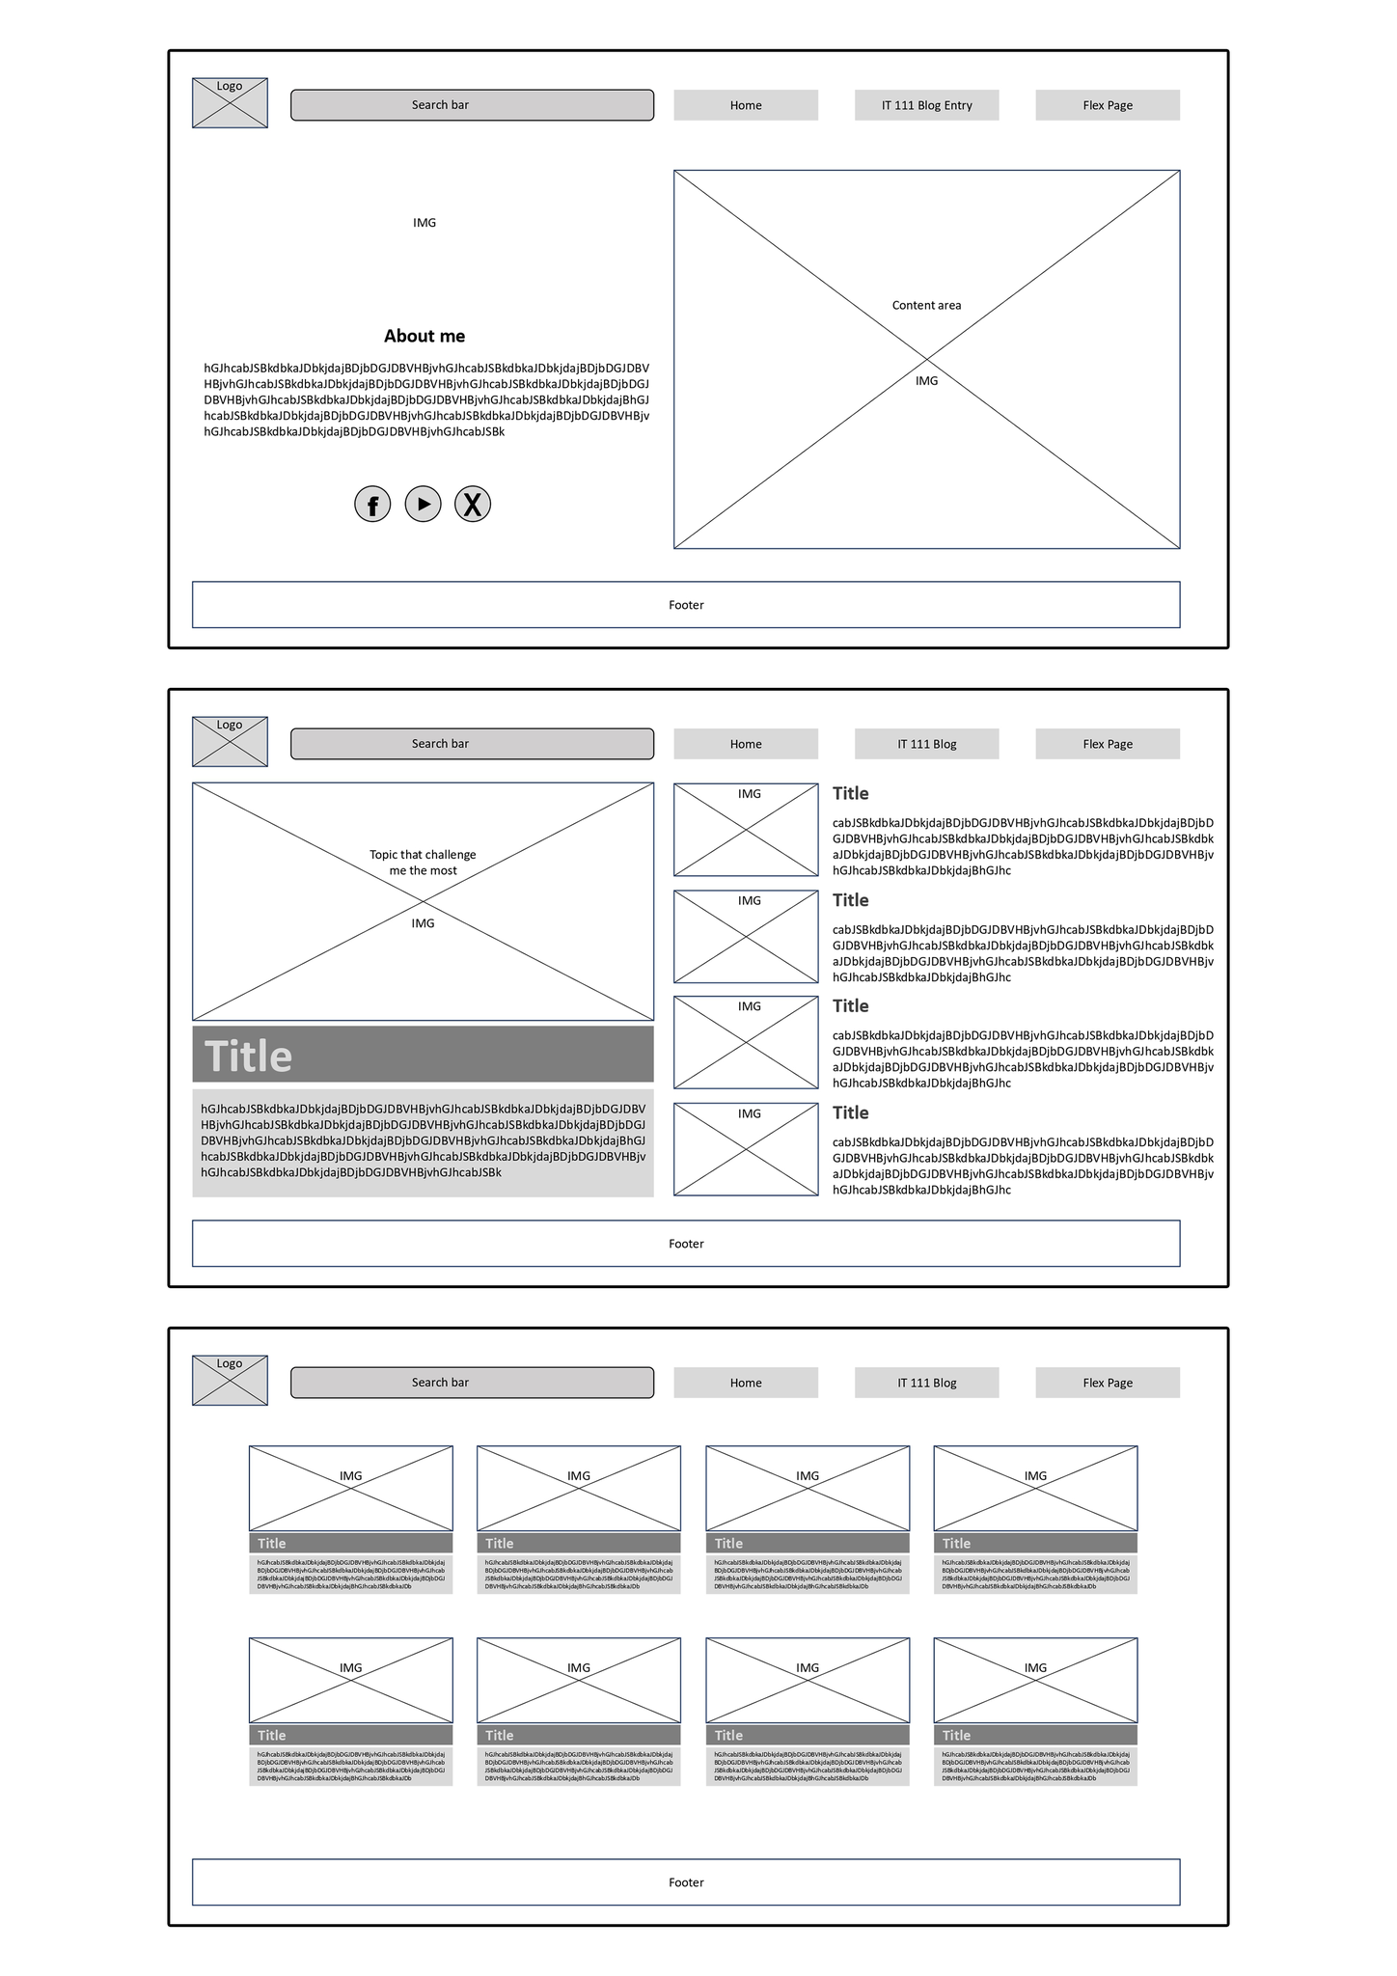***Wireframes***
2. 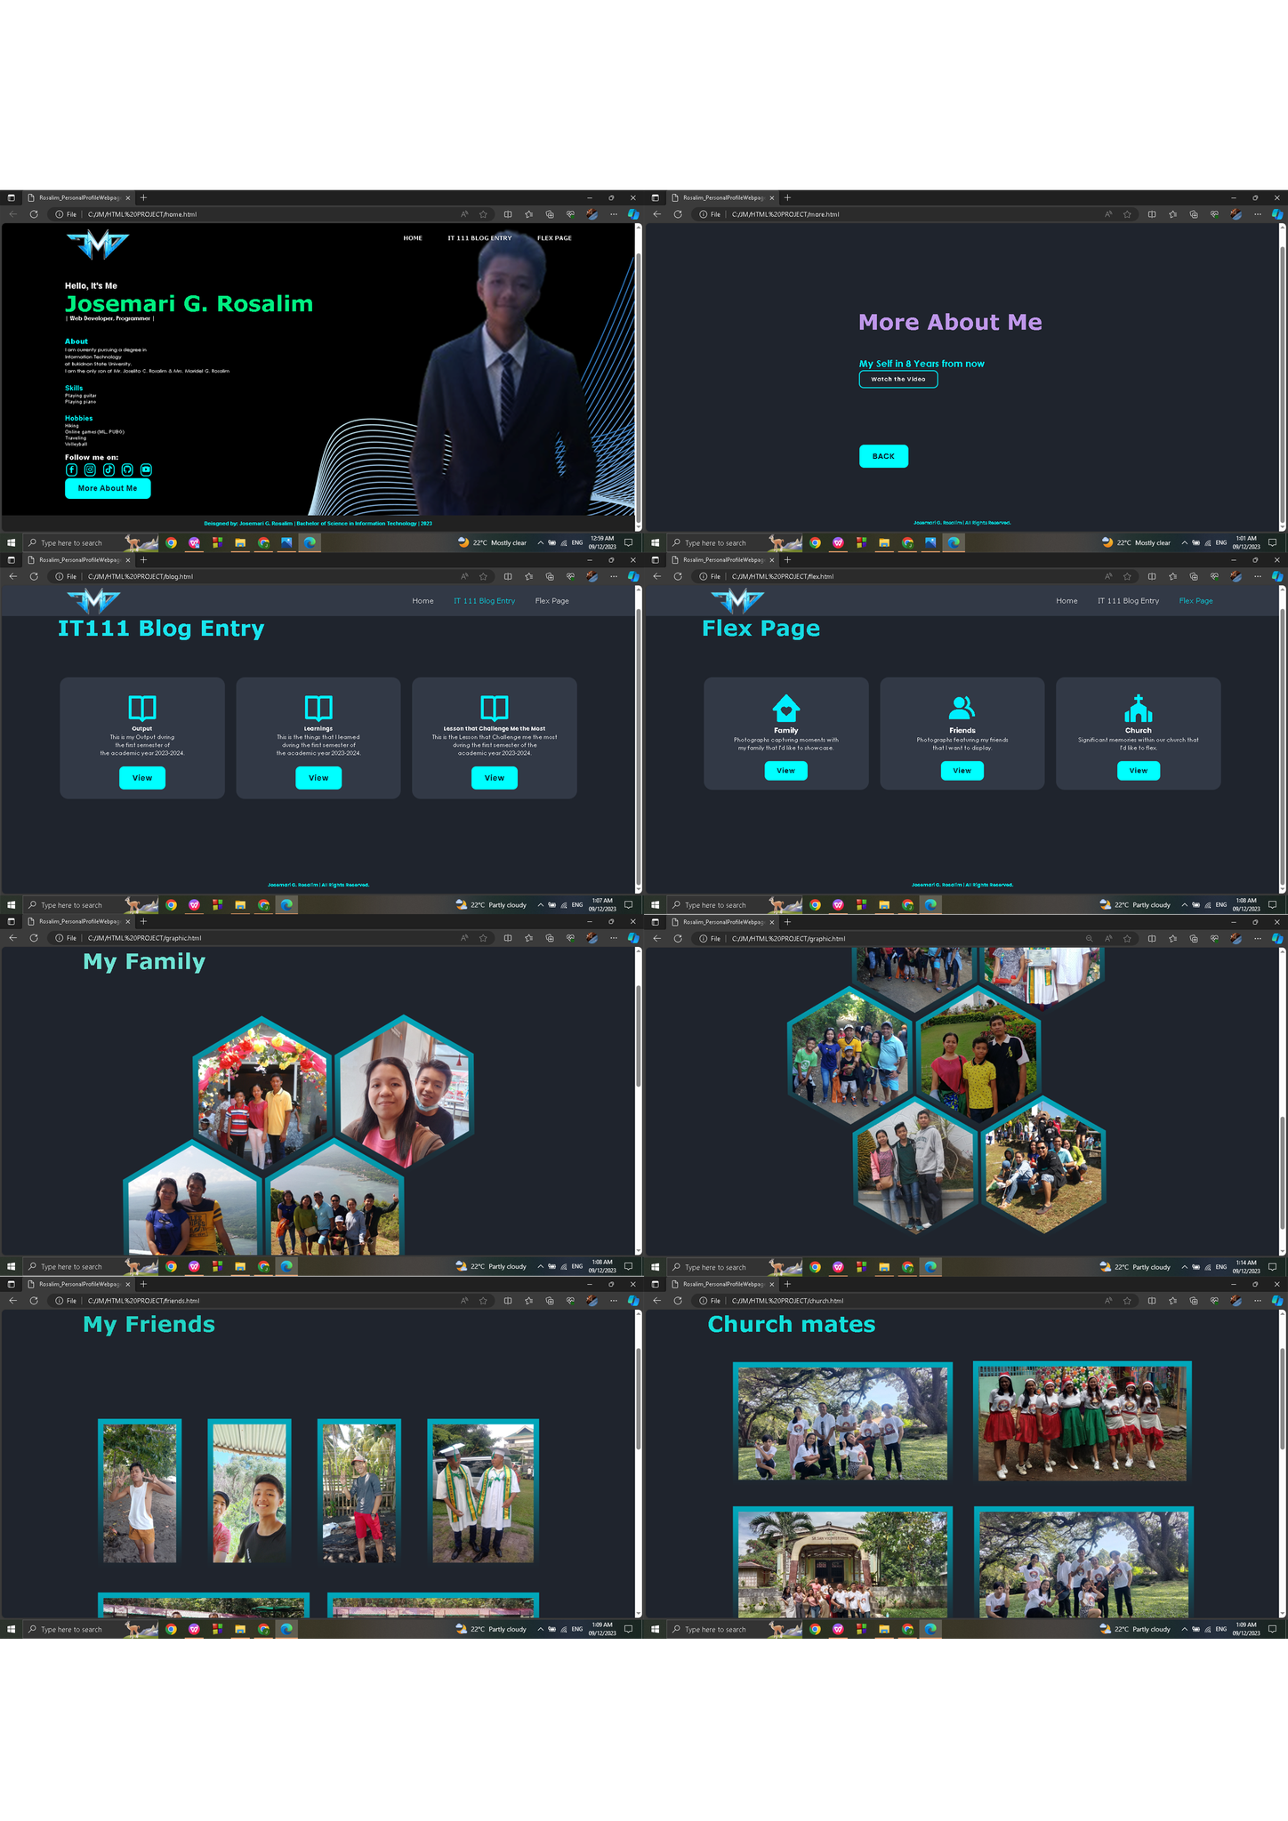***Screenshots of the Web Design***
3. ***Web Hosting Service’s Implementation Screenshots***
4. *Repository’s Code Tab Screenshot*

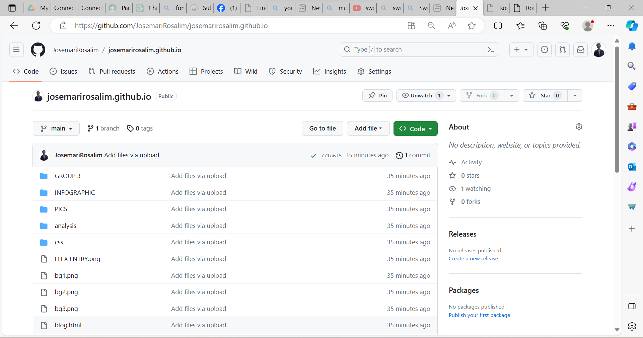

1. *Repository’s Actions Tab Screenshot (especially the pages build and deployment)*

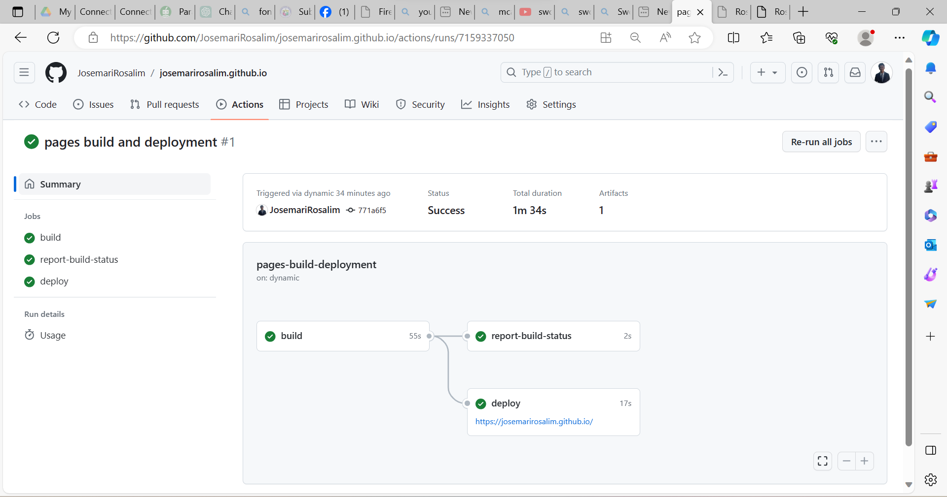

1. *Website’s URL link (e.g. <https://bongga22.github.io/luffy/)>*

*https://josemarirosalim.github.io*

1. *Homepage’s screenshot showing the entire browser and showing the URL at the address bar.*

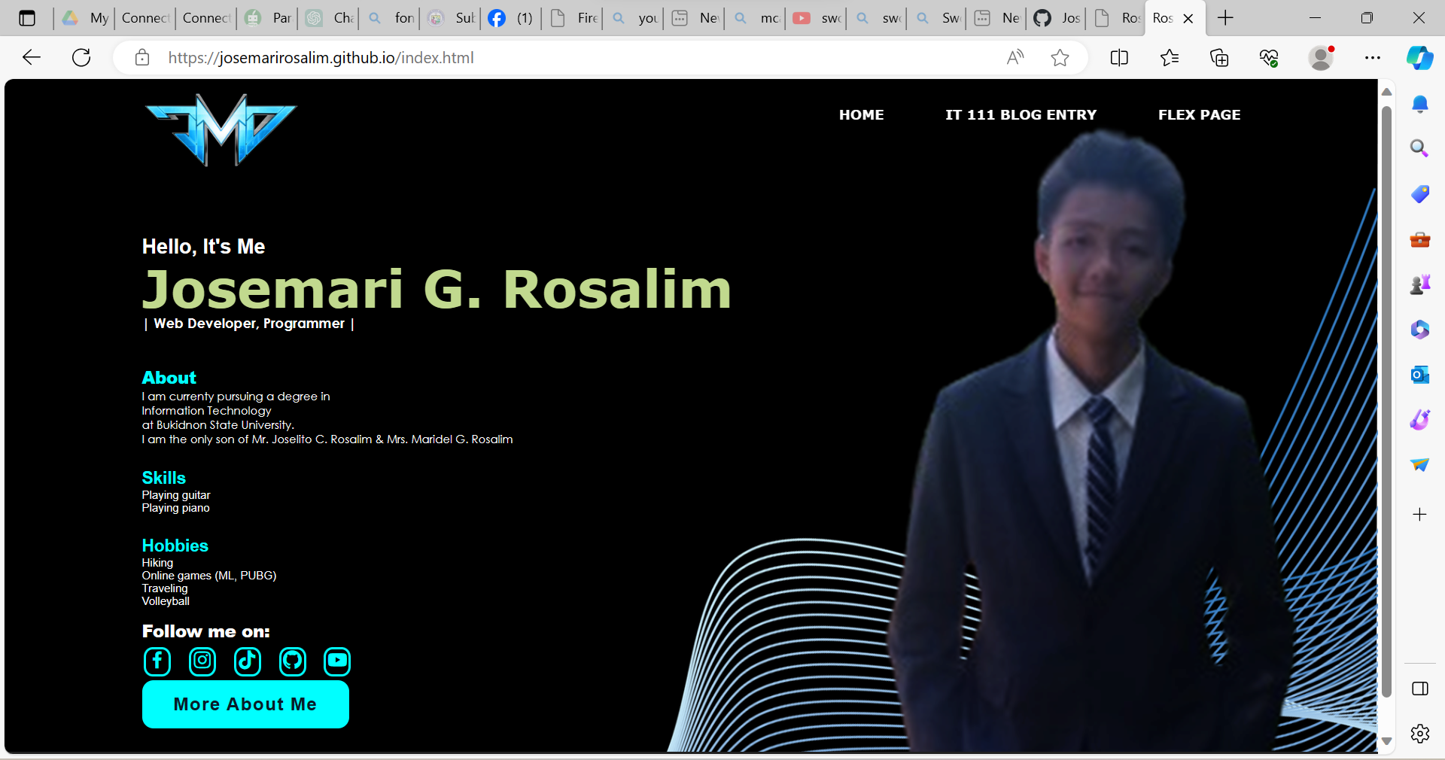

**FINAL TESTING AND CONCLUSION**

1. ***Functionality Testing***

Using GitHub as a website service uploader may be a viable solution for some functions, such as those on static websites or websites with frequent code updates, particularly for those of us who are novices or students. To ensure faultless performance and a satisfactory user experience, however, extensive functionality testing is required.

Check if GitHub's file size constraints are 25 MB. When I post my files to GitHub, I have troubles because I need to reduce the file size to be able to upload my files. It also allows the user to verify and retry failed uploads. Check the accessibility and upload retry features to ensure that keyboard navigation and screen reader compatibility are available for individuals with impairments.

1. ***II.Conclusion***

This project is a significant achievement for me this year. As a student with minimal background, expertise, and experience in this industry, witnessing the finished product is really satisfying, especially given the significant effort put in.

The development of our website has proven to be a daunting undertaking in my pursuit of a profession in information technology. It necessitates focus, self-directed study, critical thinking, and tenacity. Despite the fact that I made countless mistakes along the road, the satisfaction that comes from conquering obstacles and acquiring insights is extremely satisfying.

Every problem is a learning opportunity. While the current challenges are unpleasant, examining their intrinsic beauty and uniqueness will provide you with information and insights for future reference.

**REFERENCES**

*https://www.google.com/url?sa=i&url=https%3A%2F%2Fwww.vecteezy.com %2Fvector-art%2F16833880-github-logo-git-hub-icon-with text-on-white- background&psig=AOvVaw2DiOFxtv4DM- TM1x0XVnnz&ust=1702008148206000&source=images&cd=vfe&opi899784 49&ved=0CBIQjRxqFwoTCLDwmc24_IIDFQAAAAAdAAAAABAD*

*https://www.bing.com/search?pglt=41&q=font+.google.com&cvid=83e39fd5d5044367821fe94e8503790*